Edited SL

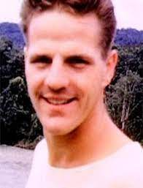

Philip James “Jim” Elliot was born in Portland, Oregon in 1927 to two loving parents Clara and Fred. Fred was a traveling preacher with the Plymouth Brethren movement. From a young age, Jim professed Christ as his savior. During the summer of 1950, Jim learned to communicate with a group of Ecuadorian indigenous people. In 1952, Jim and his friend arrived in Ecuador with the hopes of evangelizing the natives. The following year, Jim and Elizabeth, another missionary, were married in Ecuador. Jim was working with the Quechua Indians in hopes to reach the Huaorani. They decided to set up a small camp a short distance away from the Indian Village and met a few curious Huaorani that were friendly. They even gave an airplane ride to one curious man they called George. One day in January of 1956, though, ten Huaorani warriors killed Jim and his four friends. Jim Elliot always wanted to dedicate his life to God’s work and that he wanted to spread the gospel to as many people as he could. After Jim's passing, Elizabeth and their daughter Valerie were eventually able to make friends with the tribe and convert many of them to Christianity. They are now a friendly tribe and many missionaries still live there.
https://www.thegospelcoalition.org/blogs/justin-taylor/they-were-no-fools-60-years-ago-today-the-martyrdom-of-jim-elliot-and-four-other-missionaries/

